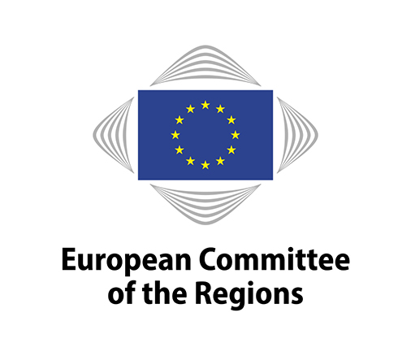
RESOL-VIII/07
168th plenary session, 14 and 15 October 2025
EN

RESOLUTION

on the proposal for the Multiannual Financial Framework 2028-2034

Submitted by the EPP, PES, Renew Europe, ECR, EA and the Greens and Progressives Groups

Resolution of the European Committee of the Regions on the proposal for the
Multiannual Financial Framework (MFF) 2028-2034

THE EUROPEAN COMMITTEE OF THE REGIONS (CoR)

Having regard to:

- the Communication from the European Commission on ‘A dynamic EU budget for the priorities of the future – The Multiannual Financial Framework 2028-2034’;
- the various legislative proposals from the European Commission that are part of the MFF 2028-2034 package and in particular the proposal COM 2025(565) final to set up a single Fund (‘the National and Regional Partnership Plans (NRPP) Fund’);
- the EU Annual Report 2025 on the State of Regions and Cities, presented on 13 October 2025.

reaffirms that the EU’s local and regional authorities (LRAs) are strategic partners for the MFF 2028-2034 as they are not only stakeholders or beneficiaries of EU funds but essential for delivering needed investments on the ground and they are the entities closest to the socio-economic reality of the territories;

is convinced that for the European Union (EU) to meet the objectives of economic, social and territorial cohesion set in the Treaty on the Functioning of the European Union and to enhance its sustainable prosperity and long-term well-being of all its inhabitants, the EU’s budget must be accessible to every territory in the EU and include allocations for all categories of regions. The governance rules of the 2028-2034 EU budget must build on an evidence-based evaluation of territorial needs in order to guarantee fairness, predictability, and long-term programming, including financing for all regions.

stresses that cohesion policy is the EU’s most important long-term instrument to invest in competitiveness, knowledge and sustainable development and fostering social inclusion, based on regional and place-based policies. Cohesion policy is a forward-looking policy that provides stability, strengthens trust, and ensures that the common market can truly function for all. While the proposal mentions the three categories of regions and funds are ring-fenced for less developed regions, the CoR demands the definition of a specific budget for cohesion policy and, at EU level, of indicative regional allocations of resources based on the current consolidated methodology that takes into account social and economic indicators. Cohesion policy should remain available to all regions and access to it should not be left solely to the discretion of national authorities;

is concerned over the disconnection between cohesion policy and the policy areas covered by the heading ‘Competitiveness, prosperity and security’ and the accelerating shift towards centrally managed funds. The CoR underlines that cohesion policy is one of the main drivers of regional competitiveness in the EU;

highlights that the new MFF proposal could aggravate the democratic deficit and undermine trust in the EU institutions due to the foreseen lack of oversight by the European Parliament and national or regional parliaments;

is alarmed that the NRPP Fund proposal could lead to further centralisation in the hands of the Commission and nationalisation of cohesion policy, fisheries and agricultural/rural development policy and put in a double competition both local and regional authorities and all the sectoral policies covered by the NRPP Fund;

firmly believes that the preparation, negotiation, implementation and monitoring of National and Regional Partnership Plans should not be left solely in the hands of central governments. Shifting decision-making to the national level, without a strong involvement of regions, would run counter to the fundamental principle of subsidiarity, substantially weaken the well-established multilevel governance and strongly contradict the partnership principle;

calls on the European Commission to revise its proposal on the NRPP Fund and on the Council and the European Parliament to echo this call. The CoR urges all parties involved to also negotiate the structure of the future MFF, recognising the widespread request from regions throughout the European Union to maintain the established practice of shared management of funds and the role of regions concerning cohesion and agricultural and rural development;

calls on national, regional and European associations of local and regional authorities, trade unions, businesses and non-governmental and civil society organisations to join forces to secure a 2028-2034 MFF able to make the EU more cohesive, resilient, social, sustainable and competitive.

Brussels, 15 October 2025.

The President
of the
European Committee of the Regions

Kata Tüttő

_____________

